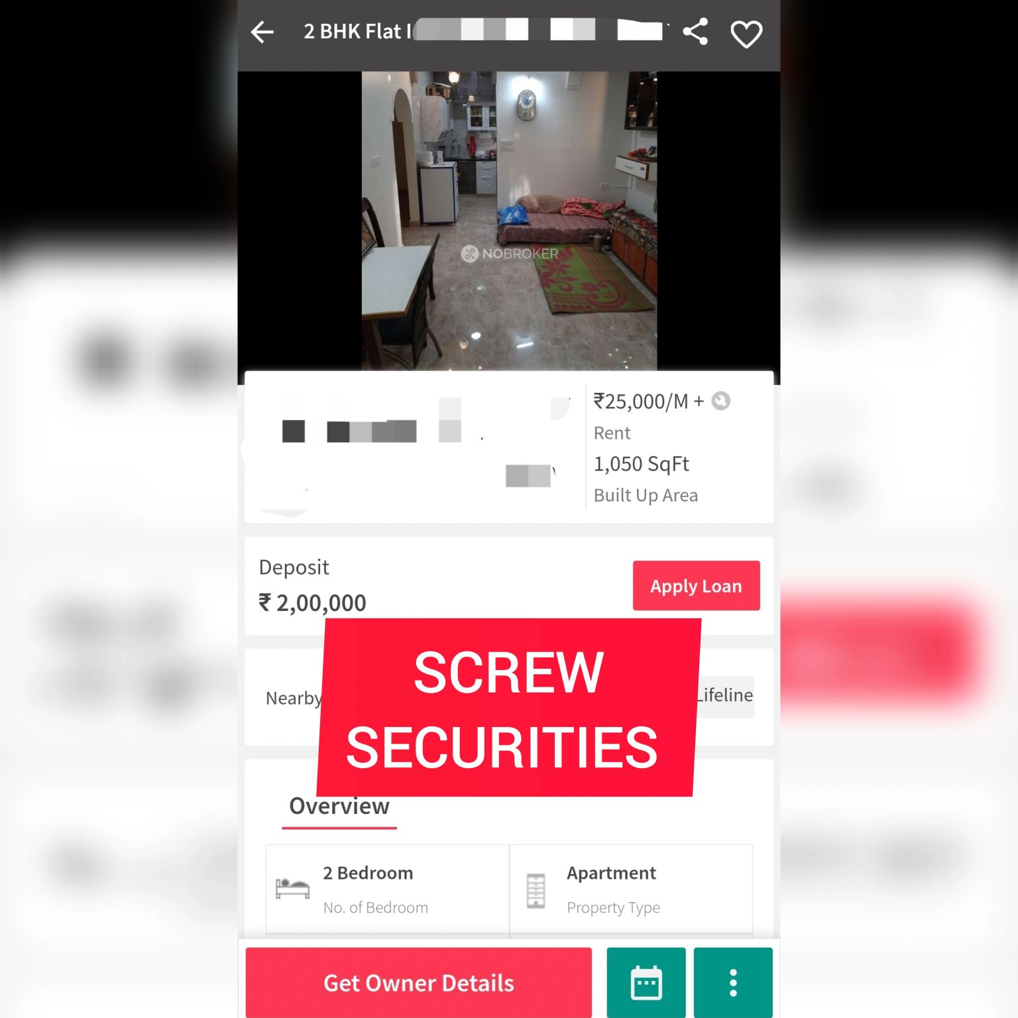

6 months of minimum deposit money in Bengaluru has to be the most normalised way of stealing.

Talking from having collected the lived experiences of a lot of students I know, who didn't know their rights well, and were intimidated into giving up the security money just makes the already exploitative system worse.

It is a story of how capitalism, migration, power dynamics, law, and economics all come together to favour one class, one sidedly, to a point where it becomes the norm.

How does an average landlord make money out of a tenant in Bengaluru?

1. Rent
2. One Month rent for re-painting costs
3. Interest on the deposit (2.5% P.A minimum by any bank rates), As told by a few brokers.

I used to wonder why some of them go so hard and fast on the exact deposit amounts,only to realise anything less would screw their mathematics up.

In a nutshell,

If you want a place to live in Bengaluru, you pay rent, maintenance and repair bills, and also allow the landlord to collect interest money with your hard earned money - and if they want, and gauge you as someone who can easily get intimidated, you probably will only get half of your security money back.

Interestingly, A lot of educational institutions too have security money in their bills that people aren't even aware could be refunded.

Do you not realise how that increases the barriers to entry to a good standard of living?

It has become an unquestioned method of -

> Gatekeeping resources

> Reinforcing Class barriers

> Optimising for profit via exploiting those already with less wealth and disposable income.

Tum kehte ho desh me Ameer, Ameer, aur Gareeb, aur bhi gareeb hote Jaa rahe hai.

This is one, stark example of how that happens- what will you do about it?

I studied it more, and found that Educational institutions in the states of Missouri and California are required by law to pay interests to students for securities held for 6 months and over a year respectively.

Imagine doing that here.

If those already above you in the financial, and power dynamic can cry of "security" and "safety", then it must come at a cost for them too.

Pay interests.

You shouldn't have to pay for a damn loan (which also will come at an interest) so someone else feels warm and cozy.

We own a flat in patna too which was rented out for a good 10 years, on a one month security, before we ourselves moved into it, and I very well know tenants can become a pain and some safety checks are needed, but the system must also know when something has really gone out of hand.

The balance must be restored.

Demand supply apni jagah hai, tum lo 6 maheene ki security. Interest idhar laao.

